**EXPERIMENT -3**

**NAME-SANCHIT JAIN**

**ENROLL-21103192**

**BATCH – B-7**

**Aim:** Verification of Superposition Theorem.

**Requirement:** Multisim live (www.multisim.com)

**Apparatus Required:**

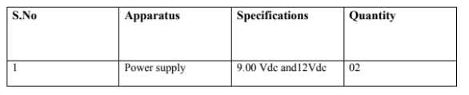

**Component Required:**

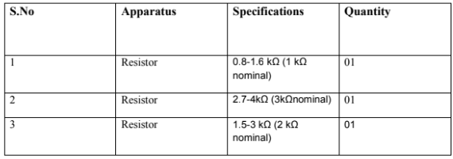

**Circuit Diagram:**

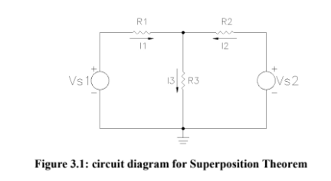

**Resistance Measurements**

|  |  |  |  |
| --- | --- | --- | --- |
| Value Determination | R1 | R2 | R3 |
| Measured | 1K | 3K | 2K |

**Voltage Supply Measurements**

|  |  |  |
| --- | --- | --- |
| Value Determination | Vs1 | Vs2 |
| Nominal | 9V | 12V |

**Measured Currents and Potentials**

|  |  |  |  |  |  |  |
| --- | --- | --- | --- | --- | --- | --- |
|  | VR1 | VR2 | VR3 | I1 | I2 | I3 |
| VS1 | 4.0909 | 4.9091 | 4.9091 | 4.0909 | 1.6364 | 2.4545 |
| VS2 | -2.18 | -9.82 | 2.18 | -2.1818 | -3.2727 | 1.0909 |
| Both | 1.9091 | -4.9091 | 7.0909 | 1.9091 | -1.6364 | 3.5455 |
| Calc d% | -0.09 | -0.03 | 0.025 | 0 | 0.006 | 0.002 |

**SNAPS**

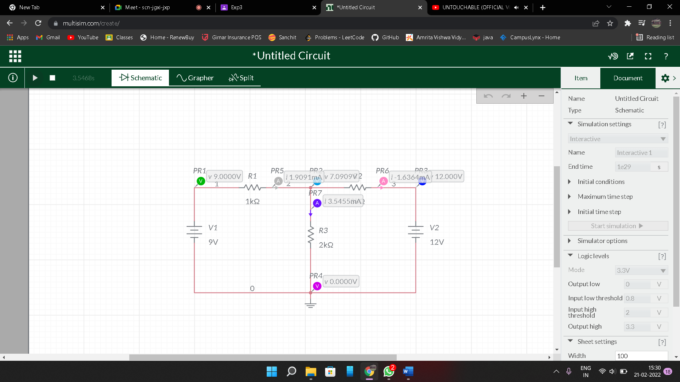

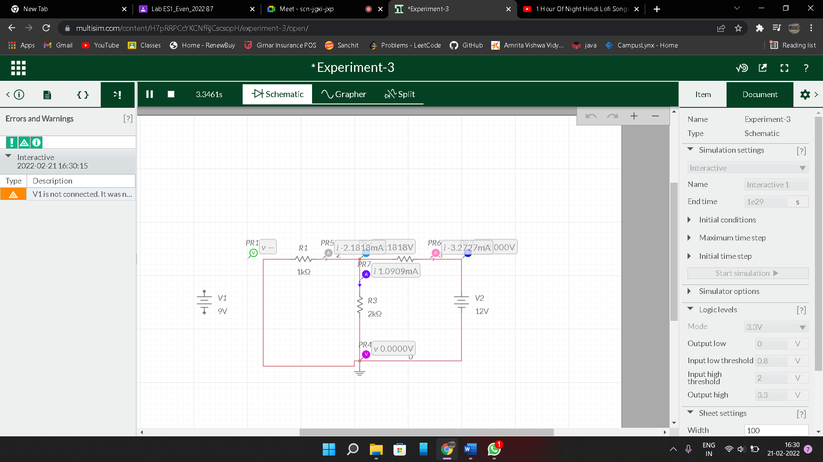

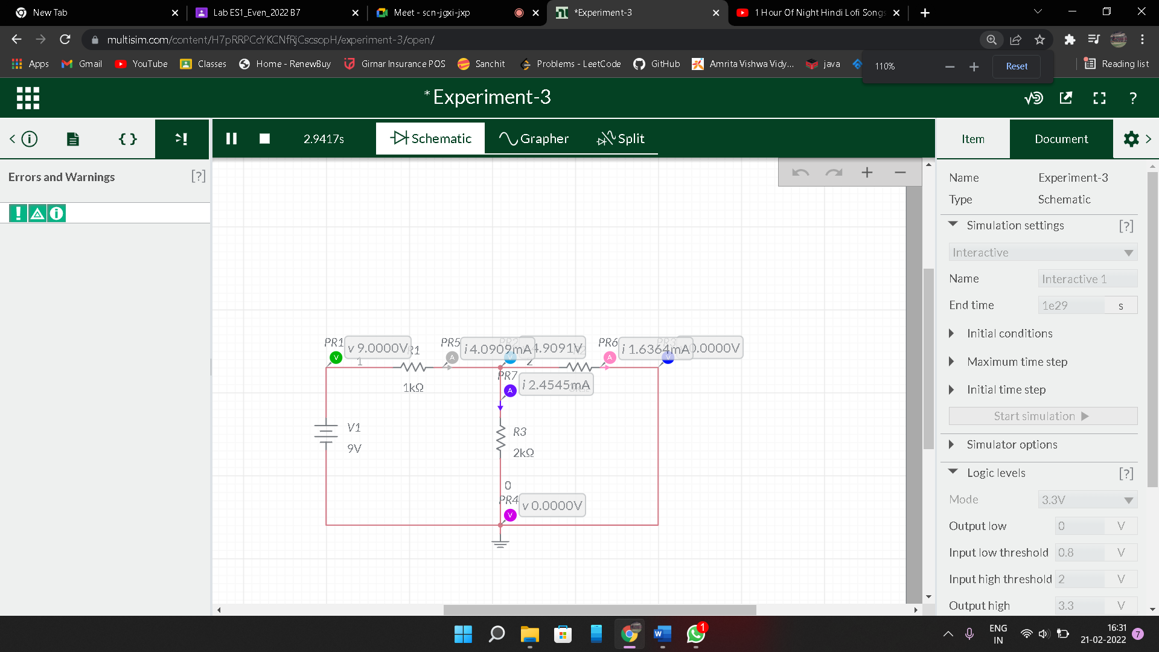

**Calculated Currents and Potentials:**

|  |  |  |  |  |  |  |
| --- | --- | --- | --- | --- | --- | --- |
|  | VR1 | VR2 | VR3 | I1 | I2 | I3 |
| VS1 | 4.08 | 4.89 | 4.9 | 4.08 | 1.63 | 2.45 |
| VS2 | -2.18 | -9.81 | 2.18 | -2.18 | -3.27 | 1.09 |
| Both | 1.92 | -4.92 | 7.08 | 1.92 | -1.64 | 3.54 |
| Calc d% | 1.041 | 0 | 0 | 1.041 | 0 | 0 |

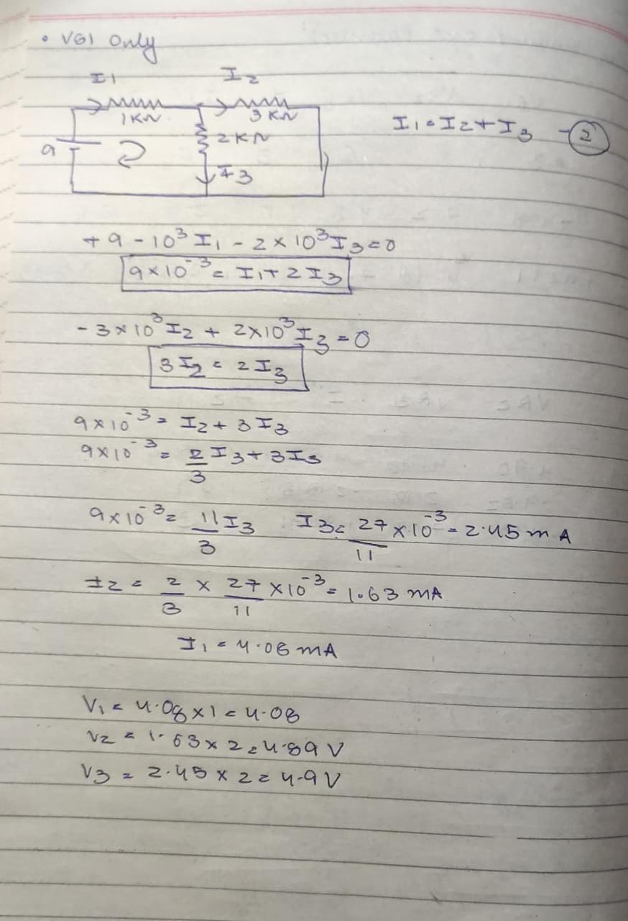

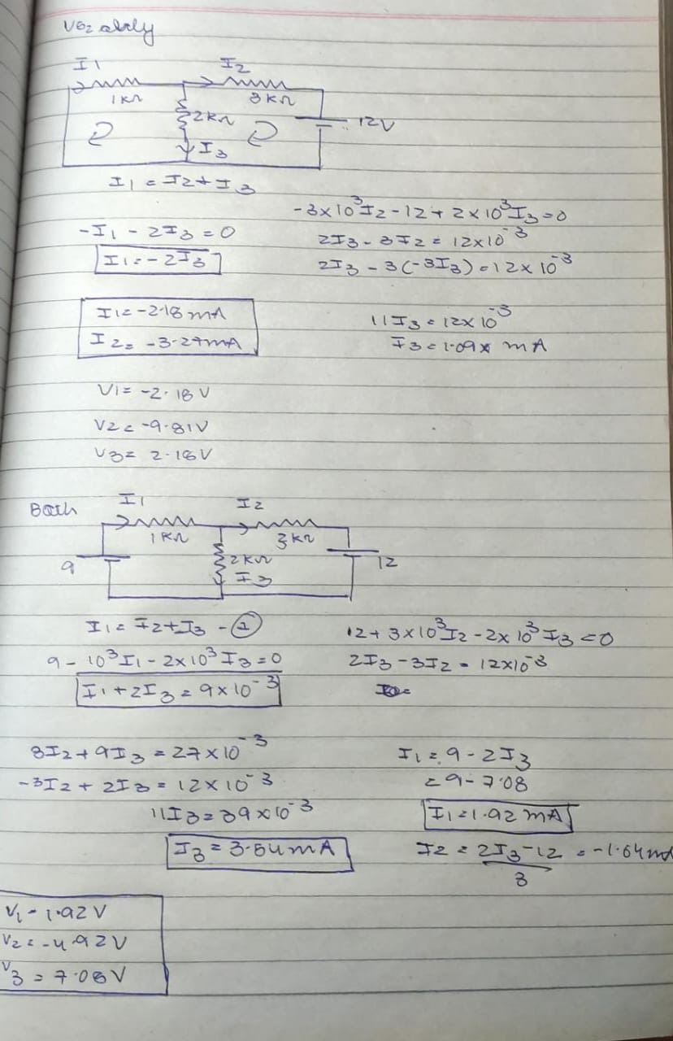**Result:**

Since the calculated d% is within the limit of error, Superposition Theorem is verified.

**Precautions:**

Circuit must be grounded

**Learning Outcomes:**

* A circuit with multiple voltage and current sources is equal to the sum of simplified circuits using just one of the sources.
* A circuit composed of two voltage sources, for example, will be equal to the sum of two circuits, each one using one of the sources and having the other removed.